Subhan Bin Yousaf

Section B

481281

FOP Assignment 3

// This code finds you the population of pakistani provinces

#include <iostream>

using namespace std;

int main() {

     int bro;

cout << "Which province's population would you like to know of: "<< endl;

cout << "1.Sindh" << endl;

cout << "2.KPK" << endl;

cout << "3.Balochistan" << endl;

cout << "4.Punjab" << endl;

cin>>bro;

switch(bro) {

case 1 : cout << "The population is 47.9 million" << endl;

break;

case 3 : cout << "The population is 12.35 million" << endl;

break;

case 4 : cout << "The population is 127 million" << endl;

break;

case 2 : cou t<< "The population is 35.53 million" << endl;

break;

default : cout << " Please type in the relevant number" << endl;

Break; }

return 0;

}

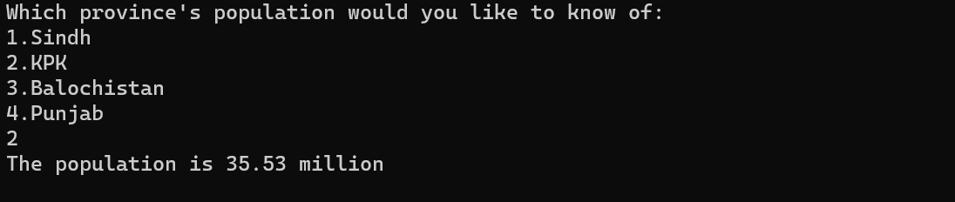

// this code finds out whether a particular letter is a vowel or a consonant

#include <iostream>

using namespace std;

int main () {

char x;

int y;

cout << " Enter your letter " << endl;

cin >> x;

if (x=='a' or x=='e' or x=='i' or x=='o' or x=='u'){

y = 1;

}

else {

y=2;

}

switch(y ) {

case 1:

cout << x <<" is a vowel"<< endl;

break;

case 2:

cout << x <<" is a consonant" << endl;

break;

default :

cout<<"Please enter a suitable letter"<<endl;

break;

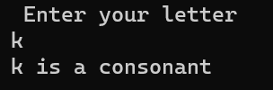 return 0;

}

}

// this code determines to see whether a number is positive or negative or a 0

#include <iostream>

using namespace std;

int main() {

int a;

int b;

cout << "Enter your number " << endl;

cin >> a;

if (a>0){

b=1;

}

else if (a==0) {

b=0;

}

else {

b=2;

}

switch (b) {

case 0 : cout << "Your number is a 0" << endl;

break;

case 1 : cout << "Your number is positive" << endl;

break;

case 2 : cout << "Your number is negative" << endl;

break;

default : cout << "Thats not even a number" << endl;

break;

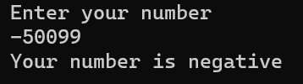 }

return 0;

}

// this code checks to see whether you’re a child or a teenager or an adult

#include <iostream>

using namespace std;

int main() {

int a;

cout << " Enter your age " << endl;

cin >> a;

if (a>0 && a<13) {

cout << "You are a child" << endl;

}

else if (a>=13 && a<20) {

cout << " You are a teenager " << endl;

}

else if (a>=20) {

cout << " You are an adult " << endl;

}

else {

cout << " Please enter the right age " << endl;

}

return 0;

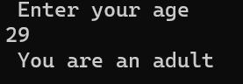}

// This code runs to check which number of the three inputs is greater

#include <iostream>

using namespace std;

int main() {

int a;

int b;

int c;

cout << " Enter First Number " << endl;

cin>>a;

cout << " Enter Second Number " << endl;

cin>>b;

cout << " Enter Third Number " << endl;

cin >> c;

if (a>b && a>c) {

cout << a << " is the greater number " << endl;

}

else if (b>a && b>c) {

cout << b << " is the greater number " << endl;

}

else if (c>a && c>b) {

cout << c << " is the greater number " << endl;

}

else {

cout << " The numbers are same " << endl;

}

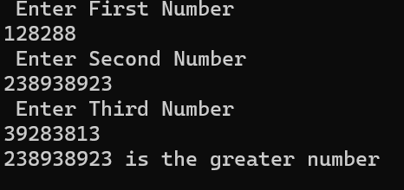 return 0;

}

// this code runs to see whether a letter is a vowel or a consonant

#include <iostream>

using namespace std;

int main() {

char a;

cout << " Enter your letter " << endl;

cin >> a;

if (a=='a' or a=='e' or a=='i'or a=='o' or a=='u') {

cout << " Your letter is a vowel " << endl;

}

else {

cout << " Your letter is a consonant " << endl;

}

return 0;

}

